**Method**

***Study Sample***

We conducted a stated preference survey of societal views on several highly polarized issues, as well as the subject’s own personal support of these issues. These beliefs included Universal Health Care (UHC), capital punishment, anthropogenic (human-caused) climate change, and slavery. Our subjects were students enrolled in a Psychology course at a Midwestern University. Participants were recruited through an online survey platform and were offered course credit in exchange for their participation.

***Survey Design and Development***

Development of the survey instrument drew on prior literature on support for universal healthcare, perspectives on deontological and utilitarian moral orientation, as well as prior work on perception of social consensus. Our social consensus manipulation exercise was adapted from work on estimation of social consensus conducted by Kobayashi and colleagues (2018). Our final survey questionnaire began by directing participants to estimate perceived social consensus on support for different social issues. Afterwards, participants received artificially high or low feedback on the degree of social consensus which allegedly exists among the population. We presented each participant with the same four highly polarized issues (support for UHC, capital punishment, climate change, and slavery); these issues were selected in order to provide variation in social characteristics, such as relative liberal/conservative leaning of issues and recent or past historical relevance. Participants then provided their level of support for our highly polarized issues after the social consensus manipulation. Support levels were captured as continuous variables ranging from 0 (strong disagreement) to 100 (strong agreement), with 50 representing relative neutrality. Participants also were measured for their deontological and utilitarian orientation, health literacy, numeracy, as well as demographic information related to gender identity, age, race/ethnicity, and year in school.

***Intervention***

Randomization of participants to either intervention condition was achieved using a randomization algorithm that guarantees each condition was selected approximately equivalent amounts of times. We subjected participants in our intervention groups to a series of preference estimation tasks. Balance was sought between the social issues chosen such that there were a variety of public policy perspectives, both liberal and conservative, presented. Participants in our ‘high’ social consensus condition were given artificially high feedback on the degree to which society agreed on the four aforementioned issues; The feedback was manipulated to be 20% higher than the actual American survey values recorded in the literature. Likewise, participants in our ‘low’ social consensus were given artificially low feedback; feedback was manipulated to be 20% lower than survey values. Participants were prevented from changing their responses in prior answers in the survey.

***Power and Statistical Analysis***

We originally planned to recruit approximately 180 participants. This minimum sample size was determined a-priori using G-power 3.1.9.7 with the following parameters: seeking the difference between two independent means (two groups), an effect size of .5, an alpha of .05, and a power of .95, for a linear multiple regression. The four highly polarized beliefs that were surveyed (climate change, death penalty, support for UHC, slavery) were all treated as continuous variables. We examined the effects of experimental condition (high or low social consensus) and individual differences (deontological and utilitarian orientation, health literacy, multiple measures of numeracy) on our outcome measure. We examined the main effect, as well as interactions between deontology and utilitarianism with our experimental conditions for our predictors. All tests were conducted in R and considered statistically significant when P <.05.

***Study 1 Hypothesis:***

Hypothesis 1: The social consensus manipulation will result in different levels of support for the highly polarized issues.

H1a: Participants in the ‘high’ social consensus manipulation will have increased support for the highly polarized issues.

H1b: Participants in the ‘low’ social consensus manipulation will have decreased support for the highly polarized issues.

Hypothesis 2: Individual differences in Utilitarian orientation will result in different levels of support for the highly polarized issues.

Hypothesis 2: Individual differences in Deontological orientation will result in different levels of support for the highly polarized issues.

**Results**

***Study Sample***

Data collection took place between February 24th and December 9th, 2023. A total of 505 responses were collected. Our final sample was primarily white (77%), female (65%), and Juniors (68%); further demographic information can be found in the table below. Participants received course credit for participation in the study.

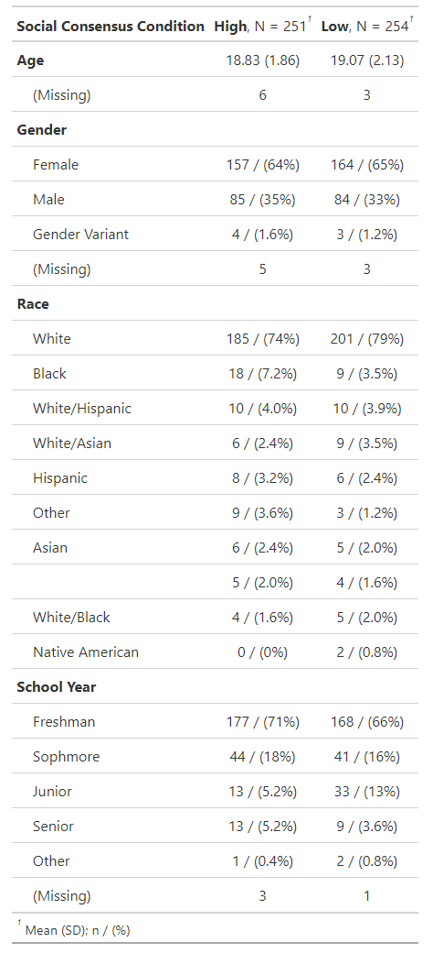

***Study Outcomes***

Descriptive statistics are summarized in the tables below. Our hypothesis was tested using a linear regression fitted to our measure for support on each highly polarized belief. In support to H1, we found that in conditions of strong social consensus, there was a statistically significant effect in our planned comparison of our active intervention condition on all four highly polarized issues. Furthermore, in support of H1a and H1b, participants in the ‘high’ and ‘low’ social consensus manipulation likewise had increased and decreased support for all four highly polarized issues. There was mixed evidence supporting H2, as individual differences in utilitarian orientation only resulted in different levels of support for the issue of slavery. Likewise, there was mixed evidence supporting H3, where individual differences in deontological orientation only resulted in differing levels of support for universal health care. Additional graphs summarizing the effect of our intervention are presented below.

